Exploratory

#this is just to archive for the code. I will post the individual charts for your review

Noah Mott

2/28/2021

library(ggplot2)

## Warning: package 'ggplot2' was built under R version 4.0.3

library(corrplot)

## Warning: package 'corrplot' was built under R version 4.0.3

## corrplot 0.84 loaded

library(corrr)

## Warning: package 'corrr' was built under R version 4.0.3

library(dplyr)

## Warning: package 'dplyr' was built under R version 4.0.3

##   
## Attaching package: 'dplyr'

## The following objects are masked from 'package:stats':  
##   
## filter, lag

## The following objects are masked from 'package:base':  
##   
## intersect, setdiff, setequal, union

library(ellipse)

## Warning: package 'ellipse' was built under R version 4.0.3

##   
## Attaching package: 'ellipse'

## The following object is masked from 'package:graphics':  
##   
## pairs

library(RColorBrewer)

## Warning: package 'RColorBrewer' was built under R version 4.0.3

library(Hmisc)

## Warning: package 'Hmisc' was built under R version 4.0.3

## Loading required package: lattice

## Loading required package: survival

## Loading required package: Formula

## Warning: package 'Formula' was built under R version 4.0.3

##   
## Attaching package: 'Hmisc'

## The following objects are masked from 'package:dplyr':  
##   
## src, summarize

## The following objects are masked from 'package:base':  
##   
## format.pval, units

library(reshape2)

## Warning: package 'reshape2' was built under R version 4.0.3

df<-read.csv('C:/Users/noahm/OneDrive/Documents/Data Science Data/Little Data/Project/cbb.csv')

justnumbers<-df %>% select(where(is.numeric)) %>%   
 glimpse()

## Rows: 1,757  
## Columns: 21  
## $ G <int> 40, 40, 40, 38, 39, 39, 38, 39, 40, 40, 36, 38, 36, 37, 37,...  
## $ W <int> 33, 36, 33, 31, 37, 35, 35, 33, 35, 36, 27, 32, 24, 29, 29,...  
## $ ADJOE <dbl> 123.3, 129.1, 114.4, 115.2, 117.8, 125.2, 123.0, 121.0, 123...  
## $ ADJDE <dbl> 94.9, 93.6, 90.4, 85.2, 86.3, 90.6, 89.9, 91.5, 90.9, 94.1,...  
## $ BARTHAG <dbl> 0.9531, 0.9758, 0.9375, 0.9696, 0.9728, 0.9764, 0.9736, 0.9...  
## $ EFG_O <dbl> 52.6, 54.8, 53.9, 53.5, 56.6, 56.6, 55.2, 51.7, 56.1, 59.5,...  
## $ EFG_D <dbl> 48.1, 47.7, 47.7, 43.0, 41.1, 46.5, 44.7, 48.1, 46.7, 48.5,...  
## $ TOR <dbl> 15.4, 12.4, 14.0, 17.7, 16.2, 16.3, 14.7, 16.2, 16.3, 15.0,...  
## $ TORD <dbl> 18.2, 15.8, 19.5, 22.8, 17.1, 18.6, 17.5, 18.6, 20.6, 18.2,...  
## $ ORB <dbl> 40.7, 32.1, 25.5, 27.4, 30.0, 35.8, 30.4, 41.3, 28.2, 29.6,...  
## $ DRB <dbl> 30.0, 23.7, 24.9, 28.7, 26.2, 30.2, 25.4, 25.0, 29.4, 27.1,...  
## $ FTR <dbl> 32.3, 36.2, 30.7, 32.9, 39.0, 39.8, 29.1, 34.3, 34.1, 29.4,...  
## $ FTRD <dbl> 30.4, 22.4, 30.0, 36.6, 26.9, 23.9, 26.3, 31.6, 30.0, 26.7,...  
## $ X2P_O <dbl> 53.9, 54.8, 54.7, 52.8, 56.3, 55.9, 52.5, 51.0, 57.4, 59.0,...  
## $ X2P_D <dbl> 44.6, 44.7, 46.8, 41.9, 40.0, 46.3, 45.7, 46.3, 44.1, 49.0,...  
## $ X3P_O <dbl> 32.7, 36.5, 35.2, 36.5, 38.2, 38.7, 39.5, 35.5, 36.2, 40.1,...  
## $ X3P_D <dbl> 36.2, 37.5, 33.2, 29.7, 29.0, 31.4, 28.9, 33.9, 33.9, 31.7,...  
## $ ADJ_T <dbl> 71.7, 59.3, 65.9, 67.5, 71.5, 66.4, 60.7, 72.8, 66.7, 69.6,...  
## $ WAB <dbl> 8.6, 11.3, 6.9, 7.0, 7.7, 10.7, 11.1, 8.4, 8.9, 10.6, 5.8, ...  
## $ SEED <int> 1, 1, 3, 3, 1, 1, 1, 1, 2, 1, 4, 3, 6, 1, 2, 9, 1, 3, 1, 1,...  
## $ YEAR <int> 2016, 2015, 2018, 2019, 2017, 2015, 2019, 2017, 2016, 2018,...

justnumbers<-justnumbers[, -which(names(justnumbers)%in% c('G', 'SEED', 'YEAR'))]

splityear<-function(year){  
 x<-df[which(df$YEAR==year),]  
 return (x)  
}  
fifteen<-df[which(df$YEAR==2015),]

str(df)

## 'data.frame': 1757 obs. of 24 variables:  
## $ TEAM : chr "North Carolina" "Wisconsin" "Michigan" "Texas Tech" ...  
## $ CONF : chr "ACC" "B10" "B10" "B12" ...  
## $ G : int 40 40 40 38 39 39 38 39 40 40 ...  
## $ W : int 33 36 33 31 37 35 35 33 35 36 ...  
## $ ADJOE : num 123 129 114 115 118 ...  
## $ ADJDE : num 94.9 93.6 90.4 85.2 86.3 90.6 89.9 91.5 90.9 94.1 ...  
## $ BARTHAG : num 0.953 0.976 0.938 0.97 0.973 ...  
## $ EFG_O : num 52.6 54.8 53.9 53.5 56.6 56.6 55.2 51.7 56.1 59.5 ...  
## $ EFG_D : num 48.1 47.7 47.7 43 41.1 46.5 44.7 48.1 46.7 48.5 ...  
## $ TOR : num 15.4 12.4 14 17.7 16.2 16.3 14.7 16.2 16.3 15 ...  
## $ TORD : num 18.2 15.8 19.5 22.8 17.1 18.6 17.5 18.6 20.6 18.2 ...  
## $ ORB : num 40.7 32.1 25.5 27.4 30 35.8 30.4 41.3 28.2 29.6 ...  
## $ DRB : num 30 23.7 24.9 28.7 26.2 30.2 25.4 25 29.4 27.1 ...  
## $ FTR : num 32.3 36.2 30.7 32.9 39 39.8 29.1 34.3 34.1 29.4 ...  
## $ FTRD : num 30.4 22.4 30 36.6 26.9 23.9 26.3 31.6 30 26.7 ...  
## $ X2P_O : num 53.9 54.8 54.7 52.8 56.3 55.9 52.5 51 57.4 59 ...  
## $ X2P_D : num 44.6 44.7 46.8 41.9 40 46.3 45.7 46.3 44.1 49 ...  
## $ X3P_O : num 32.7 36.5 35.2 36.5 38.2 38.7 39.5 35.5 36.2 40.1 ...  
## $ X3P_D : num 36.2 37.5 33.2 29.7 29 31.4 28.9 33.9 33.9 31.7 ...  
## $ ADJ_T : num 71.7 59.3 65.9 67.5 71.5 66.4 60.7 72.8 66.7 69.6 ...  
## $ WAB : num 8.6 11.3 6.9 7 7.7 10.7 11.1 8.4 8.9 10.6 ...  
## $ POSTSEASON: chr "2ND" "2ND" "2ND" "2ND" ...  
## $ SEED : int 1 1 3 3 1 1 1 1 2 1 ...  
## $ YEAR : int 2016 2015 2018 2019 2017 2015 2019 2017 2016 2018 ...

sixteen<-splityear(2016)  
seventeen<-splityear(2017)  
eighteen<-splityear(2018)  
nineteen<-splityear(2019)

summary(sixteen)

## TEAM CONF G W   
## Length:351 Length:351 Min. :24.00 Min. : 1.00   
## Class :character Class :character 1st Qu.:30.00 1st Qu.:10.00   
## Mode :character Mode :character Median :31.00 Median :16.00   
## Mean :31.43 Mean :15.71   
## 3rd Qu.:33.00 3rd Qu.:21.00   
## Max. :40.00 Max. :35.00   
##   
## ADJOE ADJDE BARTHAG EFG_O   
## Min. : 82.90 Min. : 87.8 Min. :0.0506 Min. :41.50   
## 1st Qu.: 99.05 1st Qu.: 99.1 1st Qu.:0.2717 1st Qu.:47.70   
## Median :103.20 Median :103.8 Median :0.4713 Median :49.80   
## Mean :103.87 Mean :103.9 Mean :0.4928 Mean :49.78   
## 3rd Qu.:109.00 3rd Qu.:108.4 3rd Qu.:0.7191 3rd Qu.:51.70   
## Max. :123.30 Max. :118.2 Max. :0.9703 Max. :58.70   
##   
## EFG_D TOR TORD ORB   
## Min. :42.50 Min. :13.60 Min. :10.20 Min. :17.70   
## 1st Qu.:48.15 1st Qu.:16.80 1st Qu.:16.70 1st Qu.:26.95   
## Median :49.90 Median :18.10 Median :18.10 Median :29.60   
## Mean :49.97 Mean :18.18 Mean :18.12 Mean :29.62   
## 3rd Qu.:51.70 3rd Qu.:19.45 3rd Qu.:19.40 3rd Qu.:32.20   
## Max. :59.00 Max. :25.40 Max. :25.90 Max. :42.00   
##   
## DRB FTR FTRD X2P_O   
## Min. :21.70 Min. :25.50 Min. :23.00 Min. :38.30   
## 1st Qu.:27.90 1st Qu.:33.30 1st Qu.:33.00 1st Qu.:46.30   
## Median :29.80 Median :36.80 Median :37.10 Median :48.70   
## Mean :29.82 Mean :36.64 Mean :36.94 Mean :48.66   
## 3rd Qu.:31.50 3rd Qu.:40.20 3rd Qu.:40.60 3rd Qu.:50.75   
## Max. :38.80 Max. :49.40 Max. :55.30 Max. :62.60   
##   
## X2P_D X3P_O X3P_D ADJ_T   
## Min. :41.30 Min. :27.30 Min. :28.70 Min. :61.90   
## 1st Qu.:46.60 1st Qu.:32.60 1st Qu.:33.10 1st Qu.:67.20   
## Median :48.90 Median :34.50 Median :34.80 Median :68.90   
## Mean :48.82 Mean :34.54 Mean :34.73 Mean :69.10   
## 3rd Qu.:51.05 3rd Qu.:36.40 3rd Qu.:36.35 3rd Qu.:70.85   
## Max. :59.80 Max. :43.40 Max. :42.20 Max. :81.90   
##   
## WAB POSTSEASON SEED YEAR   
## Min. :-21.900 Length:351 Min. : 1.000 Min. :2016   
## 1st Qu.:-13.200 Class :character 1st Qu.: 5.000 1st Qu.:2016   
## Median : -8.500 Mode :character Median : 9.000 Median :2016   
## Mean : -7.822 Mean : 8.779 Mean :2016   
## 3rd Qu.: -2.150 3rd Qu.:13.000 3rd Qu.:2016   
## Max. : 11.600 Max. :16.000 Max. :2016   
## NA's :283

res.cor<-correlate(justnumbers)

##   
## Correlation method: 'pearson'  
## Missing treated using: 'pairwise.complete.obs'

res.cor

## # A tibble: 18 x 19  
## term W ADJOE ADJDE BARTHAG EFG_O EFG_D TOR TORD ORB  
## <chr> <dbl> <dbl> <dbl> <dbl> <dbl> <dbl> <dbl> <dbl> <dbl>  
## 1 W NA 0.755 -0.691 0.815 0.618 -0.609 -0.467 0.139 0.296   
## 2 ADJOE 0.755 NA -0.529 0.871 0.733 -0.334 -0.601 -0.116 0.261   
## 3 ADJDE -0.691 -0.529 NA -0.852 -0.221 0.792 0.220 -0.235 -0.294   
## 4 BART~ 0.815 0.871 -0.852 NA 0.543 -0.628 -0.472 0.0544 0.311   
## 5 EFG_O 0.618 0.733 -0.221 0.543 NA -0.120 -0.368 -0.144 -0.148   
## 6 EFG_D -0.609 -0.334 0.792 -0.628 -0.120 NA 0.101 -0.0208 -0.342   
## 7 TOR -0.467 -0.601 0.220 -0.472 -0.368 0.101 NA 0.103 0.134   
## 8 TORD 0.139 -0.116 -0.235 0.0544 -0.144 -0.0208 0.103 NA 0.118   
## 9 ORB 0.296 0.261 -0.294 0.311 -0.148 -0.342 0.134 0.118 NA   
## 10 DRB -0.367 -0.267 0.348 -0.338 -0.320 0.172 0.189 0.289 0.0190  
## 11 FTR 0.127 0.0636 -0.125 0.112 -0.0835 -0.206 0.161 0.112 0.281   
## 12 FTRD -0.329 -0.382 0.181 -0.328 -0.404 0.107 0.317 0.392 0.136   
## 13 X2P_O 0.586 0.646 -0.251 0.512 0.894 -0.148 -0.289 -0.0791 -0.0913  
## 14 X2P_D -0.530 -0.329 0.728 -0.588 -0.104 0.908 0.0917 0.0272 -0.341   
## 15 X3P_O 0.433 0.579 -0.103 0.387 0.763 -0.0438 -0.333 -0.177 -0.144   
## 16 X3P_D -0.485 -0.198 0.564 -0.428 -0.101 0.722 0.0664 -0.107 -0.197   
## 17 ADJ_T -0.0161 0.0705 0.228 -0.0796 0.120 0.273 -0.103 -0.0652 -0.105   
## 18 WAB 0.905 0.852 -0.809 0.942 0.563 -0.630 -0.470 0.0948 0.332   
## # ... with 9 more variables: DRB <dbl>, FTR <dbl>, FTRD <dbl>, X2P_O <dbl>,  
## # X2P_D <dbl>, X3P_O <dbl>, X3P_D <dbl>, ADJ_T <dbl>, WAB <dbl>

plot<-res.cor %>%  
 focus(W)

plot %>%   
 mutate(term = factor(term, levels = term[order(W)])) %>%  
 ggplot(aes(x = term, y = W, fill=W)) +  
 geom_bar(stat = "identity") + scale_fill_gradientn(colours = heat.colors(6))+  
 ylab("Correlation with Wins") +  
 xlab("Variable")+coord_flip()+ggtitle('Correlation of Variables to Wins for All Teams')

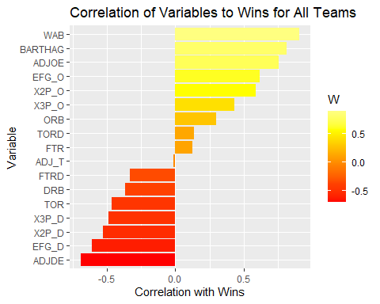

tourneyteams<-subset(df, (!is.na(df$POSTSEASON)))  
appearances<-table(tourneyteams$CONF)  
appearances<-as.data.frame(appearances)

x<-aggregate(W~CONF, data = tourneyteams, mean)  
x$W<-round(x$W, 0)

appearances%>%  
ggplot(aes(reorder(Var1, Freq), Freq))+geom_col(aes(fill=Freq))+ylab('Conference')+xlab('Number of Teams')+ggtitle('Number of Teams in Tournament per Conference 2015-2019')+scale_fill_gradient2(low='blue', high='red', mid = 'purple', midpoint = mean(appearances$Freq))+labs(x='Number')+coord_flip()

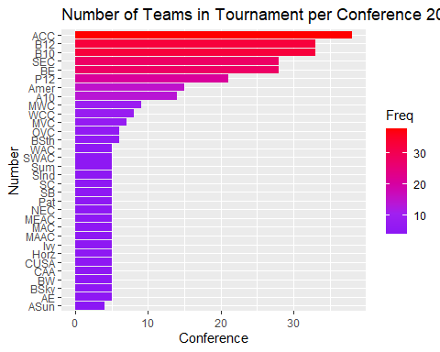

justnumbers1<-tourneyteams %>% select(where(is.numeric)) %>%   
 glimpse()

## Rows: 340  
## Columns: 21  
## $ G <int> 40, 40, 40, 38, 39, 39, 38, 39, 40, 40, 36, 38, 36, 37, 37,...  
## $ W <int> 33, 36, 33, 31, 37, 35, 35, 33, 35, 36, 27, 32, 24, 29, 29,...  
## $ ADJOE <dbl> 123.3, 129.1, 114.4, 115.2, 117.8, 125.2, 123.0, 121.0, 123...  
## $ ADJDE <dbl> 94.9, 93.6, 90.4, 85.2, 86.3, 90.6, 89.9, 91.5, 90.9, 94.1,...  
## $ BARTHAG <dbl> 0.9531, 0.9758, 0.9375, 0.9696, 0.9728, 0.9764, 0.9736, 0.9...  
## $ EFG_O <dbl> 52.6, 54.8, 53.9, 53.5, 56.6, 56.6, 55.2, 51.7, 56.1, 59.5,...  
## $ EFG_D <dbl> 48.1, 47.7, 47.7, 43.0, 41.1, 46.5, 44.7, 48.1, 46.7, 48.5,...  
## $ TOR <dbl> 15.4, 12.4, 14.0, 17.7, 16.2, 16.3, 14.7, 16.2, 16.3, 15.0,...  
## $ TORD <dbl> 18.2, 15.8, 19.5, 22.8, 17.1, 18.6, 17.5, 18.6, 20.6, 18.2,...  
## $ ORB <dbl> 40.7, 32.1, 25.5, 27.4, 30.0, 35.8, 30.4, 41.3, 28.2, 29.6,...  
## $ DRB <dbl> 30.0, 23.7, 24.9, 28.7, 26.2, 30.2, 25.4, 25.0, 29.4, 27.1,...  
## $ FTR <dbl> 32.3, 36.2, 30.7, 32.9, 39.0, 39.8, 29.1, 34.3, 34.1, 29.4,...  
## $ FTRD <dbl> 30.4, 22.4, 30.0, 36.6, 26.9, 23.9, 26.3, 31.6, 30.0, 26.7,...  
## $ X2P_O <dbl> 53.9, 54.8, 54.7, 52.8, 56.3, 55.9, 52.5, 51.0, 57.4, 59.0,...  
## $ X2P_D <dbl> 44.6, 44.7, 46.8, 41.9, 40.0, 46.3, 45.7, 46.3, 44.1, 49.0,...  
## $ X3P_O <dbl> 32.7, 36.5, 35.2, 36.5, 38.2, 38.7, 39.5, 35.5, 36.2, 40.1,...  
## $ X3P_D <dbl> 36.2, 37.5, 33.2, 29.7, 29.0, 31.4, 28.9, 33.9, 33.9, 31.7,...  
## $ ADJ_T <dbl> 71.7, 59.3, 65.9, 67.5, 71.5, 66.4, 60.7, 72.8, 66.7, 69.6,...  
## $ WAB <dbl> 8.6, 11.3, 6.9, 7.0, 7.7, 10.7, 11.1, 8.4, 8.9, 10.6, 5.8, ...  
## $ SEED <int> 1, 1, 3, 3, 1, 1, 1, 1, 2, 1, 4, 3, 6, 1, 2, 9, 1, 3, 1, 1,...  
## $ YEAR <int> 2016, 2015, 2018, 2019, 2017, 2015, 2019, 2017, 2016, 2018,...

justnumbers1<-justnumbers1[, -which(names(justnumbers1)%in% c('G', 'SEED', 'YEAR'))]  
cor.tourn<-correlate(justnumbers1)

##   
## Correlation method: 'pearson'  
## Missing treated using: 'pairwise.complete.obs'

cor.tourn

## # A tibble: 18 x 19  
## term W ADJOE ADJDE BARTHAG EFG_O EFG_D TOR TORD  
## <chr> <dbl> <dbl> <dbl> <dbl> <dbl> <dbl> <dbl> <dbl>  
## 1 W NA 0.538 -0.511 0.533 0.428 -0.415 -0.315 0.0812   
## 2 ADJOE 0.538 NA -0.389 0.799 0.593 -0.0937 -0.456 -0.210   
## 3 ADJDE -0.511 -0.389 NA -0.803 0.0770 0.708 0.105 -0.191   
## 4 BART~ 0.533 0.799 -0.803 NA 0.285 -0.425 -0.332 -0.0216   
## 5 EFG_O 0.428 0.593 0.0770 0.285 NA 0.135 -0.234 -0.288   
## 6 EFG_D -0.415 -0.0937 0.708 -0.425 0.135 NA -0.0577 0.0927   
## 7 TOR -0.315 -0.456 0.105 -0.332 -0.234 -0.0577 NA 0.0787   
## 8 TORD 0.0812 -0.210 -0.191 -0.0216 -0.288 0.0927 0.0787 NA   
## 9 ORB 0.209 0.227 -0.289 0.272 -0.269 -0.297 0.300 0.101   
## 10 DRB -0.291 -0.0970 0.228 -0.198 -0.234 0.128 0.106 0.355   
## 11 FTR -0.103 -0.189 0.0325 -0.145 -0.304 -0.0852 0.362 0.114   
## 12 FTRD -0.209 -0.265 0.0883 -0.180 -0.371 0.0577 0.192 0.501   
## 13 X2P_O 0.434 0.475 0.0420 0.232 0.866 0.102 -0.152 -0.203   
## 14 X2P_D -0.345 -0.126 0.636 -0.415 0.124 0.884 -0.0608 0.122   
## 15 X3P_O 0.237 0.491 0.0686 0.245 0.720 0.0907 -0.233 -0.279   
## 16 X3P_D -0.300 0.0104 0.417 -0.200 0.0727 0.604 -0.0191 -0.0366   
## 17 ADJ_T -0.0583 0.0945 0.285 -0.0898 0.145 0.344 -0.0497 -0.00891  
## 18 WAB 0.726 0.801 -0.754 0.895 0.319 -0.419 -0.349 -0.0187   
## # ... with 10 more variables: ORB <dbl>, DRB <dbl>, FTR <dbl>, FTRD <dbl>,  
## # X2P_O <dbl>, X2P_D <dbl>, X3P_O <dbl>, X3P_D <dbl>, ADJ_T <dbl>, WAB <dbl>

plot2<-cor.tourn %>%  
 focus(W)

plot2 %>%   
 mutate(term = factor(term, levels = term[order(W)])) %>%  
 ggplot(aes(x = term, y = W, fill=W)) +  
 geom_bar(stat = "identity") + scale_fill_gradientn(colours = heat.colors(6))+  
 ylab("Correlation with Wins") +  
 xlab("Variable")+coord_flip()+ggtitle('Correlation of Variables to Wins for Tournament Teams')

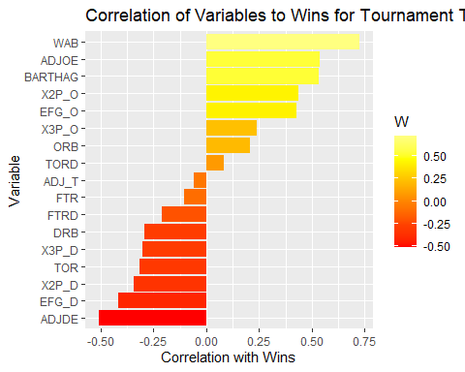

plotdata<-cor(justnumbers)  
my_colors<-brewer.pal(5, 'Spectral')  
my_colors<-colorRampPalette(my_colors)(100)  
order<-order(plotdata[1,])  
data_ordered<-plotdata[order,order]  
plotcorr(data_ordered, col=my_colors[data_ordered*50+50], mar=c(0,0,0,0))

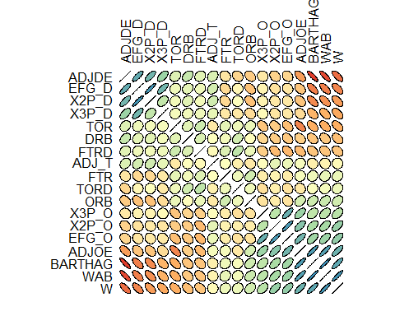

corrplot(cor(justnumbers), method='number', type='lower')

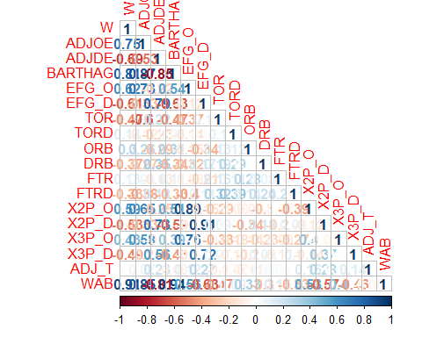

res<-rcorr(as.matrix(justnumbers))

cormat<-round(cor(justnumbers),2)  
mcormat<-melt(cormat)  
head(mcormat)

## Var1 Var2 value  
## 1 W W 1.00  
## 2 ADJOE W 0.75  
## 3 ADJDE W -0.69  
## 4 BARTHAG W 0.81  
## 5 EFG_O W 0.62  
## 6 EFG_D W -0.61

lower_tri<-cormat  
lower_tri[lower.tri(lower_tri)]<-NA

meltedcormat<-reshape2::melt(lower_tri, na.rm=TRUE)  
 ggplot(data = meltedcormat, aes(Var2, Var1, fill = value))+  
 geom_tile(color = "white")+  
 scale_fill_gradient2(low = "blue", high = "red", mid = "white",   
 midpoint = 0, limit = c(-1,1), space = "Lab",   
 name="Pearson\nCorrelation") +  
 theme_minimal()+   
 theme(axis.text.x = element_text(angle = 45, vjust = 1,   
 size = 12, hjust = 1))+  
 coord_fixed() +  
 geom_text(aes(Var2, Var1, label = value), color = "black", size = 3) +  
 theme(  
 axis.title.x = element_blank(),  
 axis.title.y = element_blank(),  
 panel.grid.major = element_blank(),  
 panel.border = element_blank(),  
 panel.background = element_blank(),  
 axis.ticks = element_blank(),  
 legend.justification = c(1, 0),  
 legend.position = c(0.6, 0.7),  
 legend.direction = "horizontal")+  
 guides(fill = guide_colorbar(barwidth = 7, barheight = 1,  
 title.position = "top", title.hjust = 0.5))

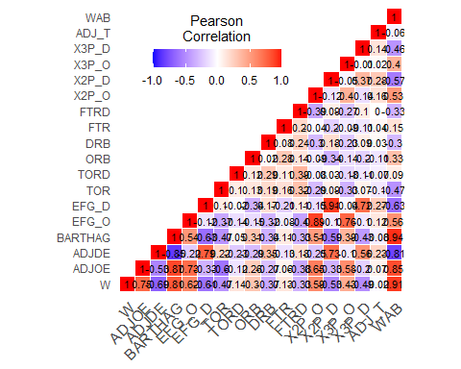

plot %>%   
 mutate(term = factor(term, levels = term[order(W)])) %>%  
 ggplot(aes(x = term, y = W, fill=W)) +  
 geom_bar(stat = "identity") + scale_fill_gradientn(colours = heat.colors(6))+  
 ylab("Correlation with Wins") +  
 xlab("Variable")+coord_flip()

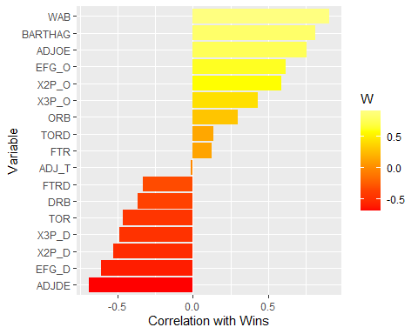

ggplot(df, aes(W, EFG_D, color=CONF))+geom_point()+ggtitle('Opponent FG Percentage Allowed vs Wins')

